041123 Basic EMG and quantitation techniques

Erik Stålberg, Department of Clinical Neurophysiology, University Hospital, Uppsala Sweden

Anatomy of the motor unit
The motor unit (MU) comprises the alpha motor neuron, its axon and all muscle fibers innervated by this axon (Sherrington, 1929). The number of MUs in each muscle is not exactly known. An electrophysiological technique of MU counting was first introduced by McComas and co-workers (McComas et al.1971). This technique and its derivatives yield an MU estimate of 100 to 500 in normal human extremity muscles.
There are few anatomical studies of human MUs. One study (Feinstein et al.1955) in humans reported a variation from 9 muscle fibers per MU in the extrinsic eye muscles to nearly 2000 in the medial gastrocnemius MU. The tibialis anterior had intermediate values, with 562 muscle fibers per MU. Electrophysiological estimates of the number of muscle fibers per MU indicated about 200 in the biceps muscle and about 300 in the tibialis anterior muscle (Gath and Stålberg, 1981).
All muscle fibers in a given MU have the same histochemical and biomechanical characteristics. Histochemical techniques have been used to classify muscle fibers according to the concentration of oxidative enzymes and myofibrillar ATPase (Brooke and Engel, 1969). The intensity of oxidative enzyme staining is related to fatigability and the ATPase level is related to the twitch characteristics.
The MU size varies considerably within the same muscle. The small MUs not only have fewer fibers, but their muscle fibers and innervating axons are also smaller in diameter (Burke and Tsairis, 1973). The small type I MUs are recruited first and therefore are called low threshold MUs. Larger MUs and proportionally more type II MUs are recruited at higher force. The orderly activation of MUs is based on the size of the ventral horn cell and is called the "Henneman's size principle" (Henneman, Somjen, Carpenter, 1965). It also reflects the size of the MU.
In normal MUs muscle fibers are randomly scattered within an area called the MU territory. This territory usually has an irregular circular shape, with a diameter of about 2-10 mm (Buchthal, Guld, Rosenfalck, 1957; Stålberg and Dioszeghy, 1991). Low threshold MUs have smaller territories than high threshold MUs. The fiber distribution is about the same in small and large MUs. The distance between nearest neighboring fibers varies from very small (fibers in contact with each other) to many hundred μm. For type I MUs, the probability of finding a muscle fiber within 300 μm of another fiber from the same MU is about 50% (Stålberg and Trontelj, 1994).
Normally each muscle fiber has one motor end-plate although dual innervation may be seen occasionally, not only in eye muscles but also in the EDC muscle (Trontelj and Stålberg, 1995). The muscle fibers have a cross sectional diameter of the order of 5-90 μm (Dubowitz and Brooke, 1973). The mean diameter of muscle fibers is around 20-30 μm in the facial muscles, 40-50 μm in the upper limb muscles and 50-60 μm in the muscles of the lower limbs (Polgar et al.1973). The muscle fiber diameter is about 10 % larger in men than in women (Brooke and Engel, 1969). All fibers of a given MU are activated synchronously, although not simultaneously. Their action potentials (APs) propagate from the end-plate to the ends of the muscle fiber with a propagation velocity of 1.5-6.5 m/sec (Stålberg, 1966), which is influenced by the fiber diameter (Håkansson, 1956).
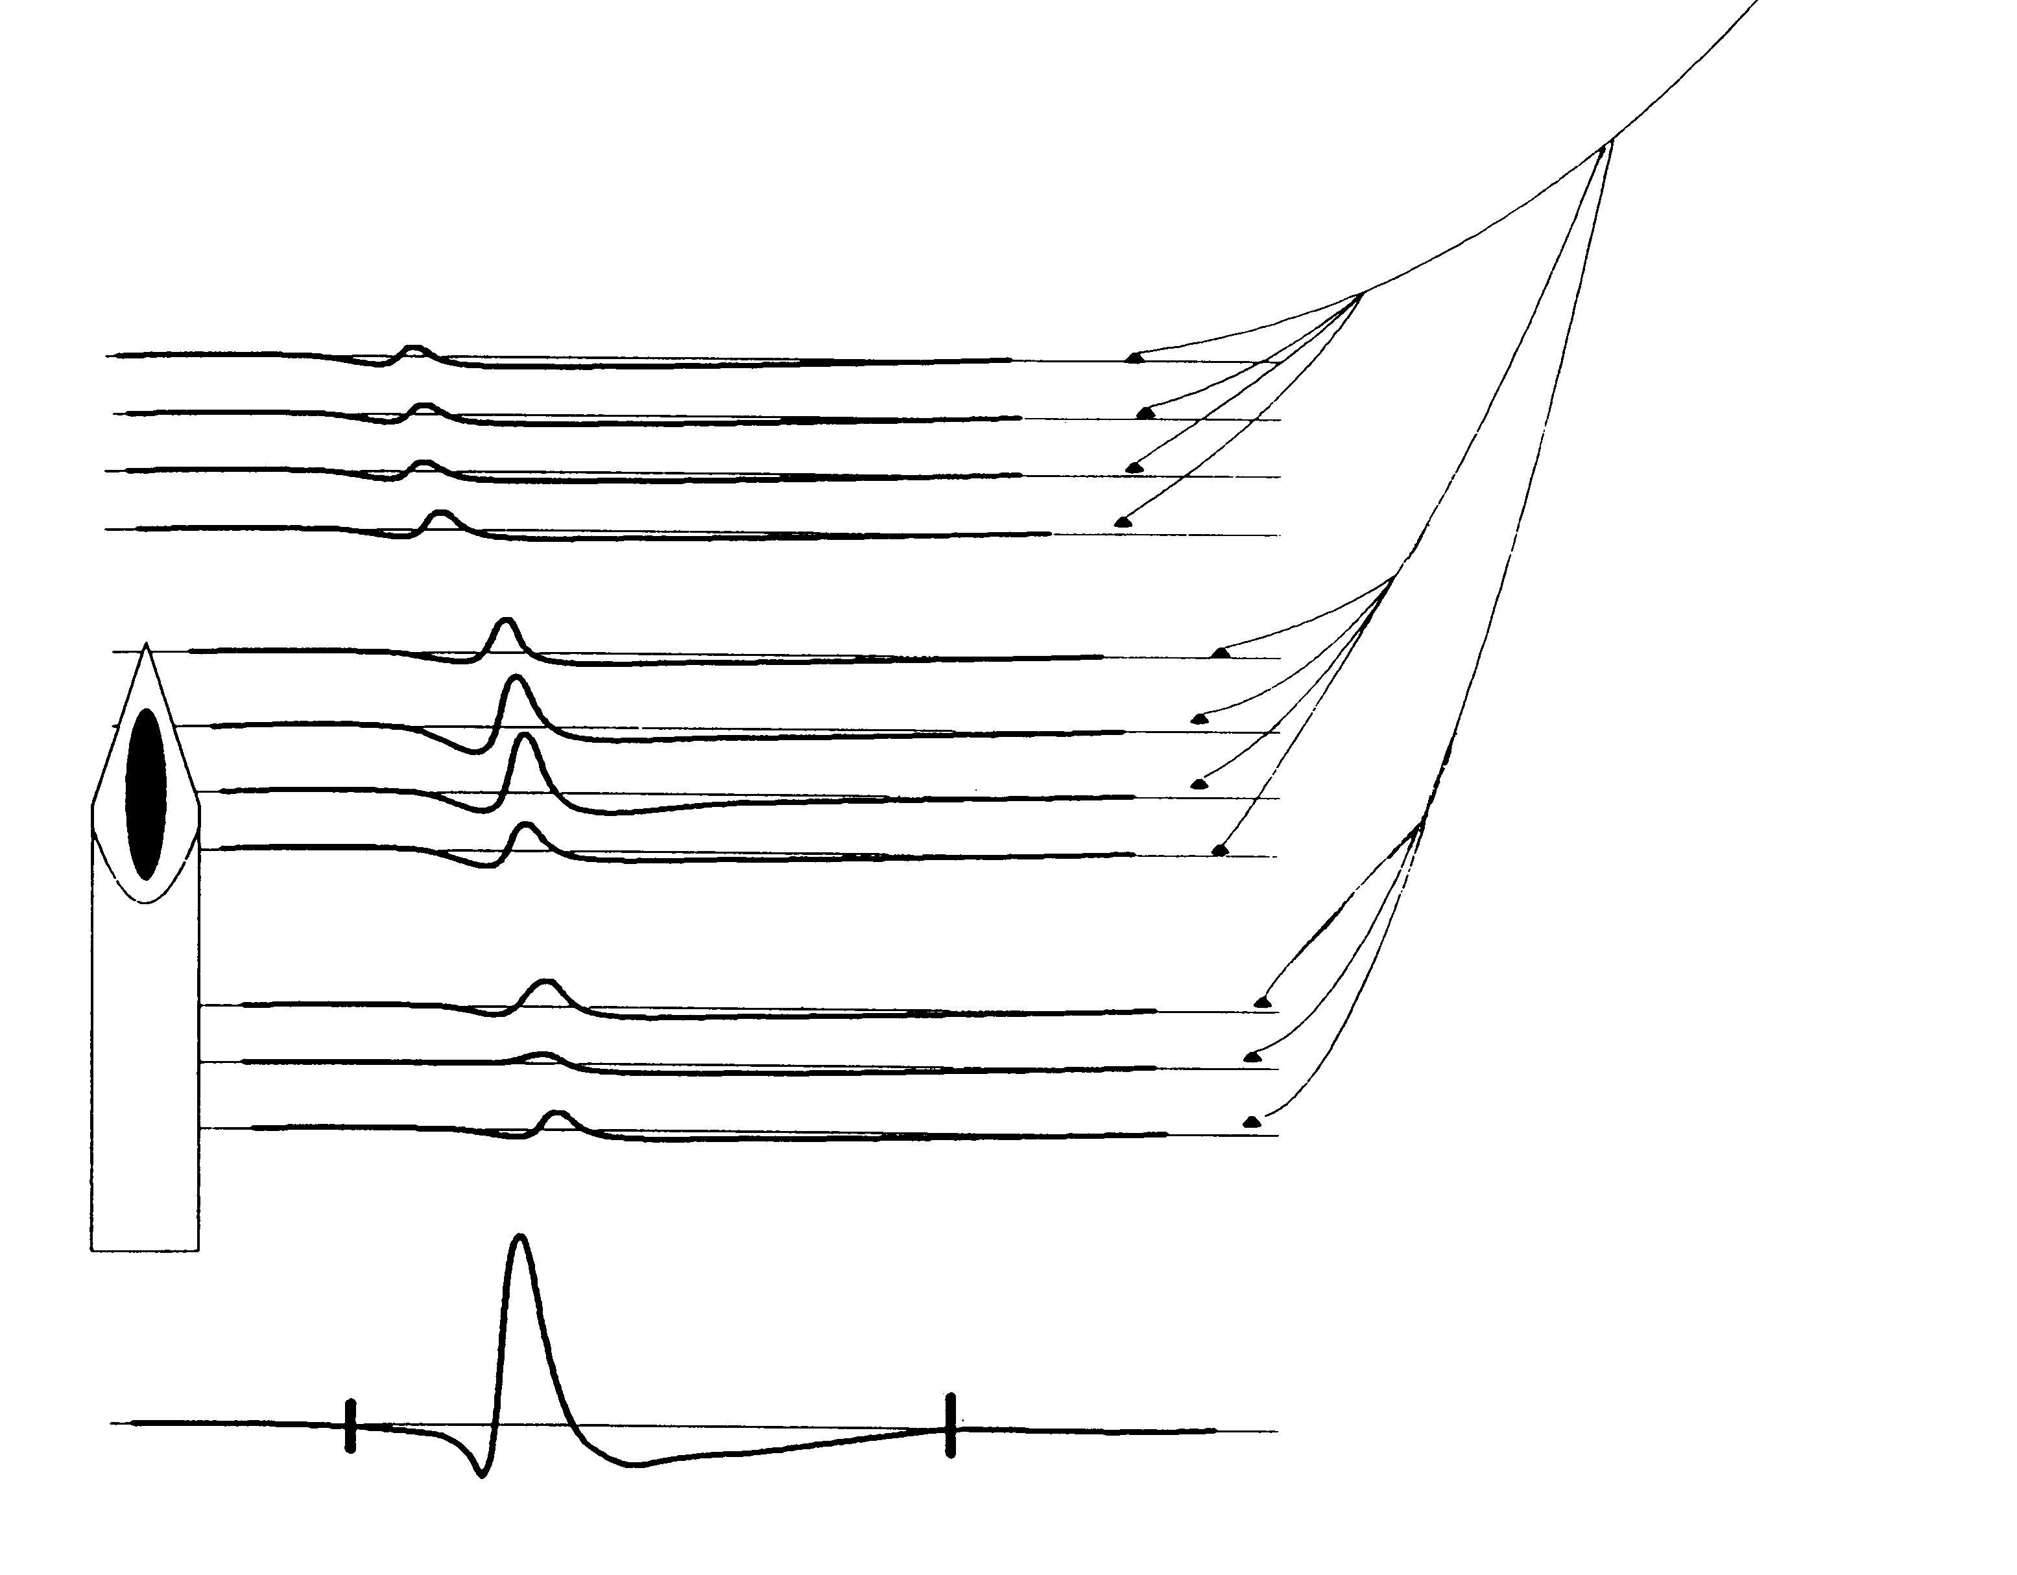
The distribution of muscle fibers can be studied with histochemical methods (Dubowitz and Brooke, 1973; Garnett et al.1979). However, these techniques are invasive and are usually restricted to only one muscle. Needle electromyography (EMG) is another method to study the MU. It is relatively non-invasive and several muscles may be studied. In diseases the microphysiology and muscle fiber topography within the MU territory and the interstitial tissue change. This produces changes in the electrical signals generated by the MU. This provides an indirect approach to study the MU structure. It has proven useful since there is a relationship between the MU architecture and the signals recorded from the MU (Buchthal, Guld, Rosenfalck, 1957; Stålberg and Ekstedt, 1973; Stålberg and Antoni, 1980). This will allow us to assess the type of structural alterations of MUs in individual muscles (neurogenic versus myogenic) and the distribution of abnormalities in the limb muscles (proximal, distal or other patterns). MUP analysis can also be used to follow up progression of neuromuscular diseases.

Electromyographic methods to study the MU
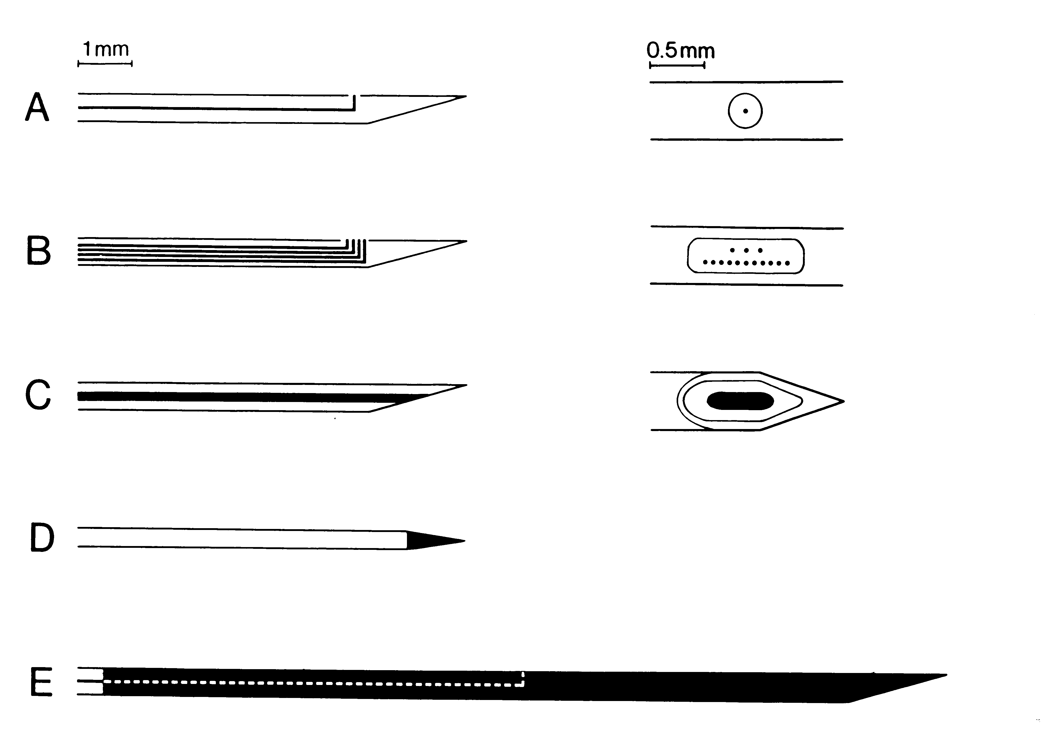
The electrophysiology of the human MU may be studied with various electromyographic methods. Due to differences in the size, shape and construction, the signals recorded by different electrodes differ in shape and amplitude. They record from different portions of the MU territory. As a result, when these techniques are used together, they provide complementary information about the MU in normal muscles and in pathology (Stålberg, 1986).

Concentric needle (CN) or monopolar needle (MN) EMG
These methods are used in routine needle EMG examination for the diagnosis of neuromuscular diseases. The first EMG needle electrode was developed by Adrian and Bronk in 1929. This was a CN electrode that has not changed significantly in the last seven decades. The standard modern CN consists of a 150 μm diameter wire inside a hollow metal cylinder, the cannula. The tip is ground to a 15 degree angle, producing an elliptical recording surface (150 x 580 μm) which has an area of 0.07 mm2. CN electrodes with a smaller recording surface area, and therefore different recording characteristics than the conventional electrode, are also available. In the CN, the cannula serves as the reference electrode. The MN electrode is an insulated metal wire with a conical recording surface which has an area of 0.25 mm2. A separate surface electrode is used as reference.
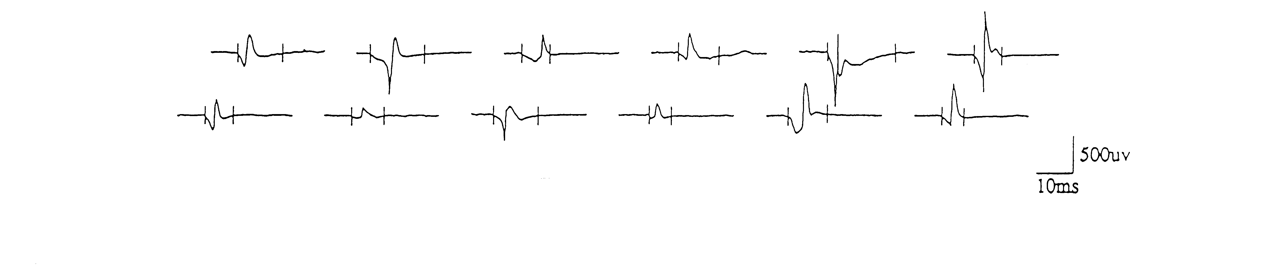
In routine EMG investigations, the muscle is studied during rest, during slight voluntary activation for single MU studies and during strong voluntary contraction, for the assessment of the so called interference pattern.

Single fiber EMG (SFEMG)
This technique is used to study the muscle fiber membrane characteristics, muscle fiber propagation velocity, function of individual motor end-plates, organization of muscle fibers in the MU territory, reflexes and central influences (Stålberg and Trontelj, 1994).
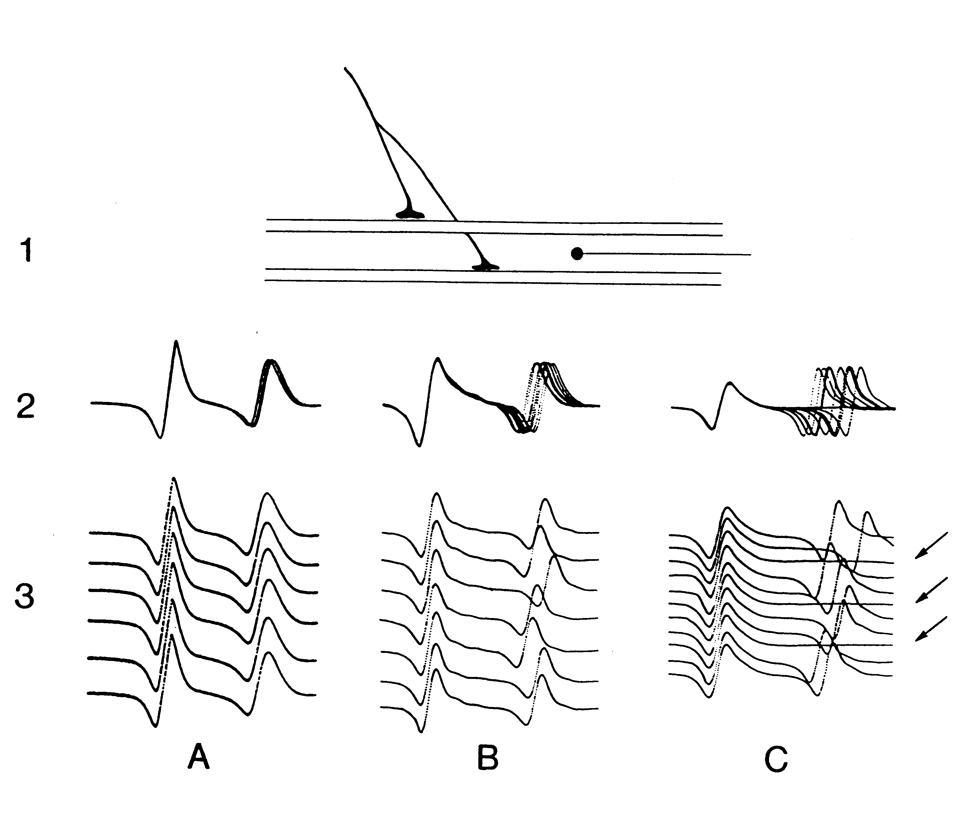
As a refinement of the needle EMG, SFEMG has shed new light on the microphysiology of the motor unit.

Macro EMG
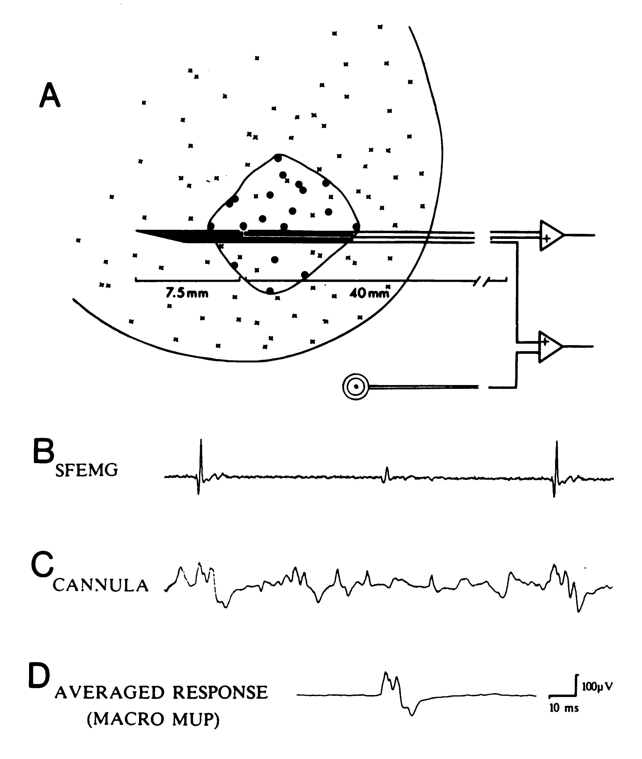
Macro EMG is used to assess the MU size. Macro EMG provides information about the electrical activity of the entire motor unit (Stålberg, 1980). The large recording surface of the electrode measures action potentials from a larger proportion of the motor unit than conventional EMG electrodes and provides more information about the motor unit than monopolar, concentric or SFEMG recordings. The technique has been described in detail elsewhere (Stålberg 1980, Stålberg and Fawcett 1982).

Surface EMG
Surface EMG recordings with spike triggering (Stålberg, 1977; Stålberg and Fawcett, 1982; Masuda and Sadoyama, 1986; Brown, Strong, Snow, 1988; Schneider, Rau, Silny, 1989; Roeleveld, Falck, Stålberg, and Stegeman, 1997) are used to assess MU size, propagation velocity and end-plate distribution.

Scanning EMG

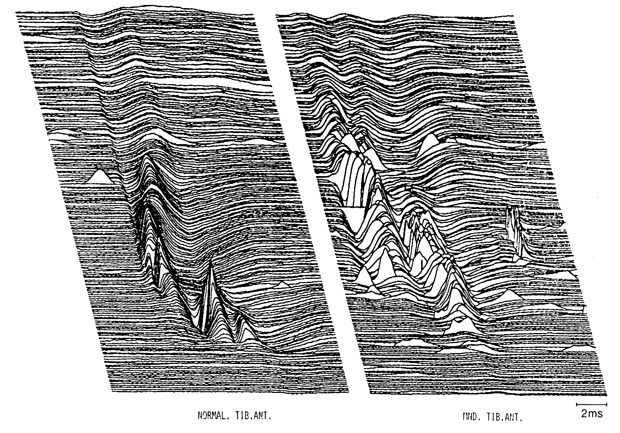
The cross section of the MU, the territory, can be studied with multi-electrodes (Buchthal, Guld, Rosenfalck, 1957; Stålberg et al.1976) or with scanning EMG (Stålberg and Antoni, 1980). This technique has not been used in routine, but for research purposes. It requires a special device to pull an EMG electrode through the motor unit.

Methods for quantitative analysis
A number of quantitative methods have been developed, some of which have been introduced for a wider use in routine. For detailed descriptions, the reader is referred to individual publications (Stålberg,Trontelj 1994; Kopec, Hausmanowa 1976; McGill, Dorfman, 1989; Stashuk, De Luca, 1989; Stålberg et al 1995, Nandekar et al 1995, Sanders et al, 1996, Stålberg, 1980).

Method | Parameters | Principle methods  for analysis
SFEMG | Jitter | time intervals
 | FD | manual
 | Prop vel | time intervals
Conc or monopolar EMG | MUP shape descriptors | manual
 |  | decomposition
 | IP | turns-ampl
 |  | frequency spectrum
Macro EMG | Macro MUP ampl,dur | spike triggered averaging
Surface EMG | Global | RMS, frequency spectrum
 | Individual MUP | spike triggered averaging
Motor unit counting | Size and # of MUs | axonal stimulation
 |  | spike triggered averaging
 |  | variance analysis
Scanning EMG | MUP shape descriptors | shape analysis
 | Territory size | manual

Bibliography

Brooke MH, Engel WK. The histographic analysis of human muscle biopsies with regard to fiber types. Neurology 1969;19:221-33.

Brown WF, Strong MJ, Snow R. Methods for estimating numbers of motor units in biceps-brachialis muscles and losses of motor units with aging. Muscle Nerve 1988;11:423-32.

Buchthal F, Guld C, Rosenfalck P. Multielectrode study of the territory of a motor unit. Acta Physiol Scand 1957;39:83-103.

Burke RE, Tsairis P. Anatomy and innervation ratios in motor öunits of cat gastrocnemius. J Physiol (Lond) 1973;234:749-65.

Dubowitz V, Brooke MH. Muscle Biopsy: A Modern Approach, Vol. 2. WB Saunders ltd,London 1973;2nd-475.

Feinstein B, Lindegård B, Nyman E, Wohlfart G. Morphologic studies of motor units in normal human muscles. Acta Anat 1955;23:127-42.

Garnett RAF, O'Donovan MJ, Stephens JA, Taylor A. Motor unit organization of human medial gastrocnemius. J Physiol 1979;287:33-43.

Gath I, Stålberg E. In situ measurements of the innervation ratio of motor units in human muscles. Exp Brain Res 1981;43:377-82.

Håkansson CH. Conduction velocity and amplitude of the action potential as related to circumference inthe isolated fibre of frog muscle. Acta Physiol Scand 1956;37:14-34.

Henneman E, Somjen G, Carpenter DO. Functional significance of cell size in spinal motor neurones. Ann Plast Surg 1965;28:560-89.

Kopec J, Hausmanowa-Petrusewicz I. On line computer application in clinical quantitative electromyography. Electromyogr Clin Neurophysiol 1976;16:49-64.

Masuda T, Sadoyama T. The propagation of single motor unit potentials detected by a surface electode array. Electroenceph Clin Neurophysiol 1986;63:590-8.

McComas AJ, Fawcett P, Campbell MJ, Sica REP. Electrophysiological estimation of the number of motor units within a human muscle. J Neurol Neurosurg Psychiatry 1971;34:121-31.

McGill K, Dorfman L. Automatic decomposition electromyography (ADEMG), methodologic and technical considerations. In: Desmedt JE, ed.Computer Aided Electromyography and Expert Systems. Clinical Neurophysiology Updates. 1989;91-101.

Nandedkar, S.D., Barkhaus, P.E., and Charles, A. Multi-Motor Unit action potential analysis (MMA). Muscle Nerve 1995;18:1155-1166.

Polgar J, Johnson MA, Weightman D, Appleton D. Data on fiber size in thirty-six human muscles. J Neurol Sci 1973;19:307-18.

Roeleveld, K., Stegeman, D.F., Falck, B., and Stålberg, E. Motor unit size estimation: confrontation of surface EMG with macro EMG. Electroencephalogr Clin Neurophysiol 1997;105:181-188.

Sanders, D.B., Stålberg, E., and Nandedkar, S.D. Analysis of the electromyographic interference pattern. J Clin Neurophysiol 1996;13(5):385-400.

Schneider J, Rau G, Silny J. A noninvasive EMG technique for investigating the exciation progration in single motor units. Electromyogr Clin Neurophysiol 1989;22:273-80.

Sherrington CS. Ferrier Lecture - some functional problems attaching to convergence. Proc R Soc Lond 1929;105:332-62.

Stashuk D, DeLuca C. Update on the decomposition and analysis of EMG signals. In: Desmedt JE, ed.Computer Aided Electromyography and Expert Systems. Clinical Neurophysiology Updates. 1989;39-53.

Stålberg E. Propagation velocity in single human muscle fibres. Acta Physiol Scand 1966;suppl 287:1-112.

Stålberg E. Electrogenesis in human dystrophic muscle. In: Rowland LP, ed.Pathogenesis of human muscular dystrophies. 1977;570-87.

Stålberg E. MACRO EMG, a new recording technique. J Neurol Neurosurg Psychiatry 1980;43:475-82.

Stålberg E. Single fiber EMG, macro EMG, and scanning EMG. New ways of looking at the motor unit. CRC Crit Rev Clin Neurobiol 1986;2:125-67.

Stålberg E, Antoni L. Electrophysiological cross section of the motor unit. J Neurol Neurosurg Psychiatry 1980;43:469-74.

Stålberg E, Dioszeghy P. Scanning EMG in normal muscle and in neuromuscular disorders. Electroencephalogr Clin Neurophysiol 1991;81:403-16.

Stålberg E, Ekstedt J. Single fibre EMG and microphysiology of the motor unit in normal and diseased human muscle. In: Desmedt J, ed.New developments in EMG and Clinical Neurophysiology. 1973;113-29.

Stålberg, E., Falck, B., Sonoo, M., and Åström, M. Multi-MUP EMG analysis-a two year experience with a quantitative method in daily routine. Electroencephalogr Clin Neurophysiol 1995;97:145-154,.

Stålberg E, Fawcett P. Macro EMG changes in healthy subjects of different ages. J Neurol Neurosurg Psychiatry 1982;45:870-8.

Stålberg E, Schwartz M, Thiele B, Schiller H. The normal motor unit in man. J Neurol Sci 1976;27:291-301.

Stålberg E, Trontelj JV. Single Fiber Electromyography in Healthy and Diseased Muscle. 2nd ed. New York: Raven Press; 1994; 291 pps.

Trontelj JV, Stålberg E. Multiple innervation of muscle fibers in myasthenia. Muscle Nerve 1995;18:224-8.

