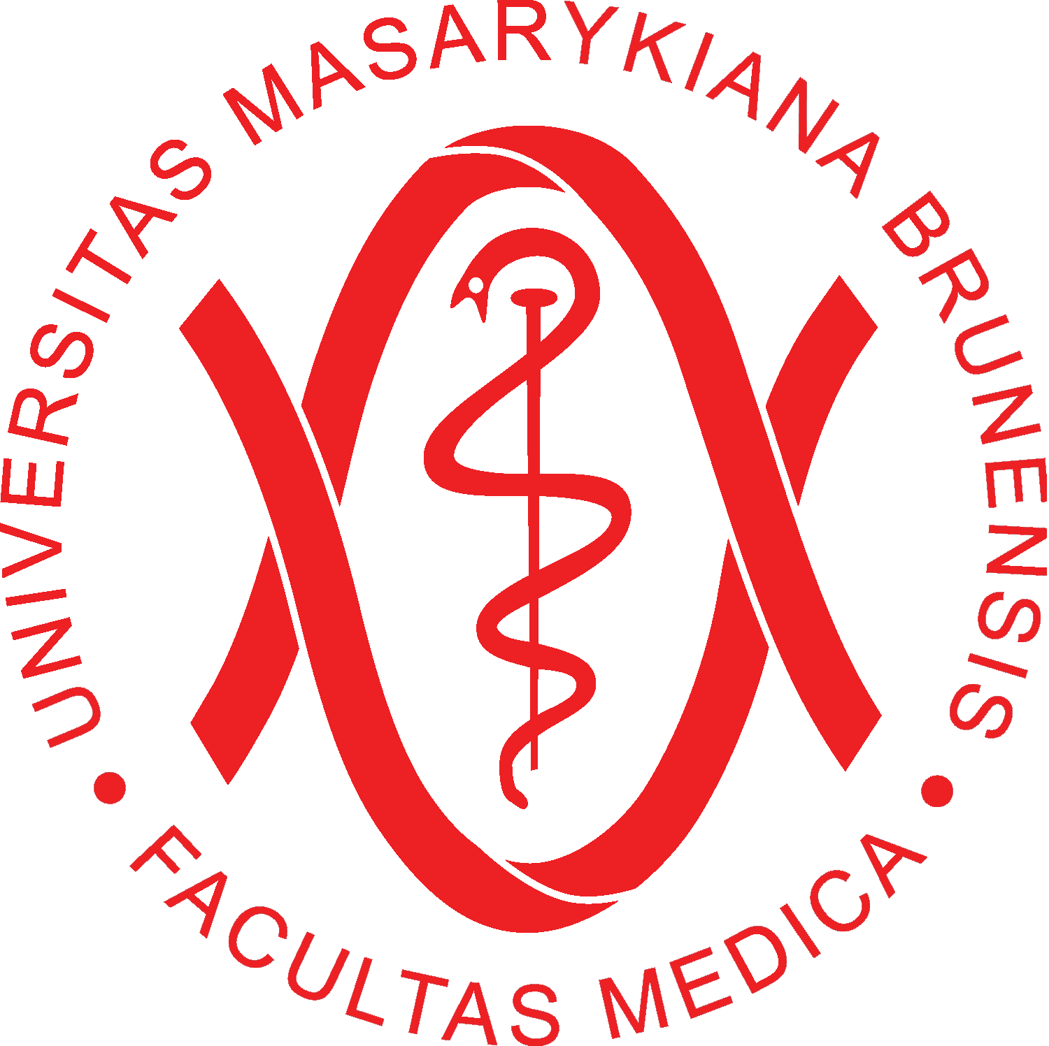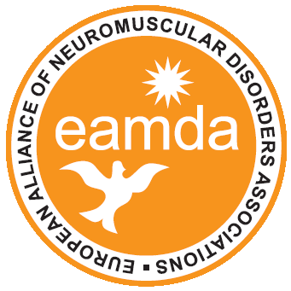

TREAT-NMD training course:
“Best practice implementation in the management of patients with NMDs”
Prague, CZECH REPUBLIK – September 8, 2011
Location: Clarion Congress Hotel Prague, Freyova 33, 190 00 Praha 9, Vysocany

Registration Form

Name:_________________________________________________________________________

Title (Dr. / Prof. / other)___________________________________________________________

Affiliation: _____________________________________________________________________

Address:_______________________________________________________________________

City/Zip/State:__________________________________________________________________

Phone:_________________________________ Fax: ___________________________________

Email: ________________________________________________________________________

Qualification (M.D. / Ph.D. / other): _________________________________________________

Medical specialties (if any): _______________________________________________________

Fields of interest in myology: _____________________________________________________

Special diet (vegetarian / others): ___________________________________________________

Comments:

MAIL (including CV in English) TO: Mrs. Katelijne Senden at senden@enmc.org

